SCUBA-2 Block Specification
command_translator_m_op_table

Table of Contents

1. Block Overview 3
1.1 Block Location and Block Interface Within System 3
1.2 Block Functionality / Features 3
1.3 Block Dataflow 3
2. Block Interfaces 4
2.1 Interface Signal Description 4
2.2 Interface Protocol and Timing 5
3. High-Level Description 6
3.1 State Machine Description 6
3.2 State Machine Outputs 7
4. Files of the Block 10
4.1 Source Code 10
4.1.1 rx_control_fsm.vhd 10

Block Overview

Block Location and Block Interface Within System
This block is located on the clock card FPGA. It interfaces with the following blocks on the clock card:
- cmd_translator

Block Functionality / Features
- This block keeps track of macro operation commands (macro_ops) issued by cmd_translator.
- It stores the card address, parameter ID, frame sequence number, and macro_op sequence number of any issued macro_op.
- On the completion of a macro_op it will be retired from the table.

Block Dataflow
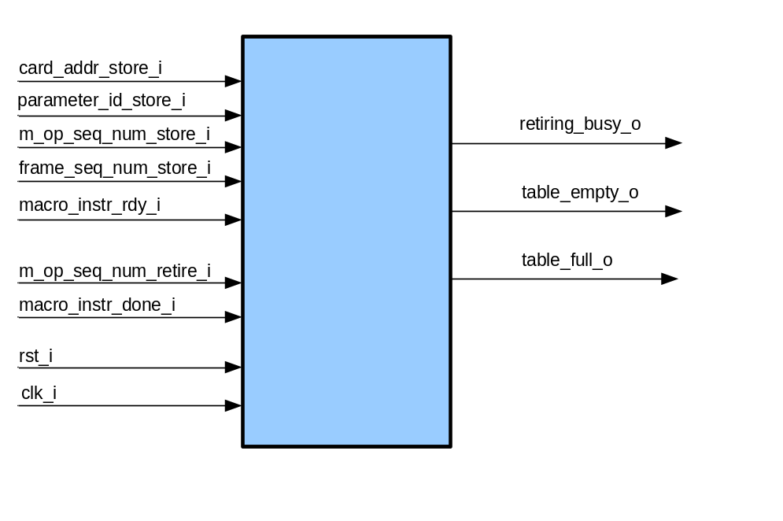

Block Interfaces

Interface Signal Description
- Interface Signals
Signal | Description | Direction
Global Signals
clk_i | Global clock signal | in
rst_i | Global asynchronous active-high reset | in
Control Signals
macro_instr_rdy_i | Asserted high when an issued macro_op is ready to be stored in the table. | in
macro_instr_done_i | Asserted high when a completed macro_op is ready to be retired from the table | in
retiring_busy_o | Asserted high during the retirement of a macro_op. During this time NO other macro_op should be stored or retired. That is macro_instr_rdy_i should not be asserted, nor should macro_instr_done_i be re-asserted.  Furthermore, when ‘macro_instr_done_i’ is asserted high (to retire a macro_op) it should stay high until ‘retiring_busy_o’ goes high, then it should go low. | out
table_empty_o | Asserted high when the macro_op table is empty. When high there are no macro_ops in the table so a retire request should never be issued. | out
table_full_o | Asserted high when the macro_op table is full. When high no more commands should be attempted to be stored in the table. | out
Data Signals
card_addr_store_i | Card address vector of macro_op to be stored. | in
parameter_id_store_i | Parameter ID vector of macro_op to be stored. | in
m_op_seq_num_store_i | Sequence number vector of macro_op to be stored. | in
frame_seq_num_store_i | Sequence number vector of frame. | In
m_op_seq_num_retire_i | Sequence number vector of macro_op to be retired. | in

card_addr_store_i, parameter_id_store_i, m_op_seq_num_store_i, frame_seq_num_store_i

Interface Protocol and Timing

When an issued macro_op is to be stored into the store_retire table, the appropriate macro_op values are written to the entity inputs ‘card_addr_store_i’, ‘parameter_id_store_i’, ‘m_op_seq_num_store_i’, and ‘frame_seq_num_store_i’, and ‘macro_instr_rdy_i’ is asserted high. On the positive going edge of ‘macro_instr_rdy_i’ the macro_op values are latched into the lowest available free slot of the macro_op store_retire table. The internal vector ‘table_status’ flags which table slots are currently occupied (element =’1’) and which are free (element = ‘0’). The input signal ‘macro_instr_rdy_i’ should not be asserted when the output signal ‘retiring_busy_o’ is high.

To initiate a macro_op retirement its sequence number is written to ‘m_op_seq_num_retire_i’, and ‘macro_instr_done_i’ is asserted high. This initiates a finite state machine (FSM) to find and retire the macro_op. A high on the output signal ‘retiring_busy_o’ indicates that the FSM has begun looking for the command in the table. Once high the input ‘macro_instr_done_i’ can be pulled low (note that the FSM will not return to it’s IDLE state until ‘macro_instr_done_i’ has returned low). The FSM uses one state to find the macro_op (a positive edge on the FSM output signal ‘find_mop’ initiates the search), and one state to retire the macro_op (a positive edge on the FSM output signal’retire_mop’ initiates the retirement of the macro_op).

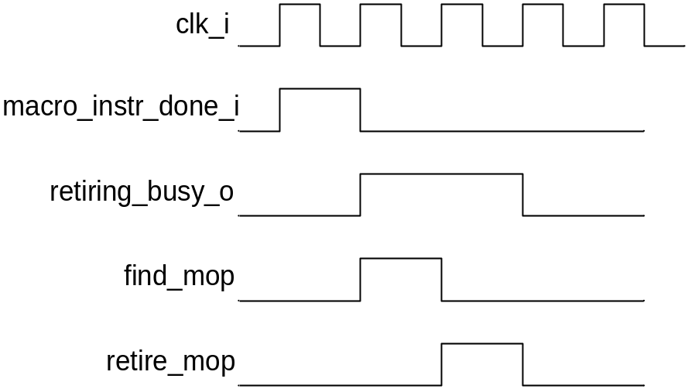

High-Level Description

Block Description

The entity contains four processes and a FSM. A brief description of each is provided below:

- store_retire_table: process(rst_i, update_table)
This process controls the storing and retiring of commands to the macro_op table. On a positive edge of the signal ‘updata_table’ either a new macro_op is stored in the table or a macro_op is retired from the table. If the input signal ‘macro_instr_rdy_i’ is high then a macro_op is stored in the table at the address determined by the signal ‘store_pointer’. If ‘macro_instr_rdy_i’ is low then the macro_op at the address pointed to by ‘retire_pointer’ is retired from the table.

- find_store_pointer: process(rst_i, macro_instr_rdy_i, table_status)
This process establishes the next available free slot in the table for the next macro_op to be stored to. It uses ‘table_status’ to establish which slots are free and assigns the lowest available address to the address pointer ‘store_pointer’.

- find_retire_pointer: process(rst_i, find_mop)
This process is initiated by the FSM when there is a macro_op to be retired. When the FSM asserts its output ‘find_mop’, this process searches the table for the macro_op to be retired and once found assigns its table address to the pointer ‘retire_pointer’.

- table_full_empty(table_status)
This process uses the vector ‘table_status’ to establish if the store_retire table is full or empty. If ‘table_status’ contains all ‘1’s then the table is full and the output ‘table_full_o’ is asserted high. If ‘table_status’ contains all ‘0’s then the table is empty and the output ‘table_empty_o’ is asserted low. Note that no macro_op should be written to the table when ‘table_full_o’ is asserted and that if a command is to be retired when ‘table_empty_o’ is asserted then an error must have occurred.

- FSM
The finite state machine controls the retirement of macro_ops. It is initiated by a high on the input signal ‘macro_instr_done_i’. The FSM has three outputs ‘retiring_busy_o’, ‘find_mop’, and ‘retire_mop’. When ‘find_mop’ is asserted the process ‘find_retire_pointer’ finds the macro_op’s address, and when ‘retire_mop’ is asserted the process ‘store_retire_process’ retires the macro_op. During the entire retirement stage the output ‘retiring_busy_o’ is asserted high. The FSM only returns to its IDLE state if the input ‘macro_instr_done_i’ has returned low. The FSM’s transition state diagram and output assignments are described below.

FSM Transition State Diagram

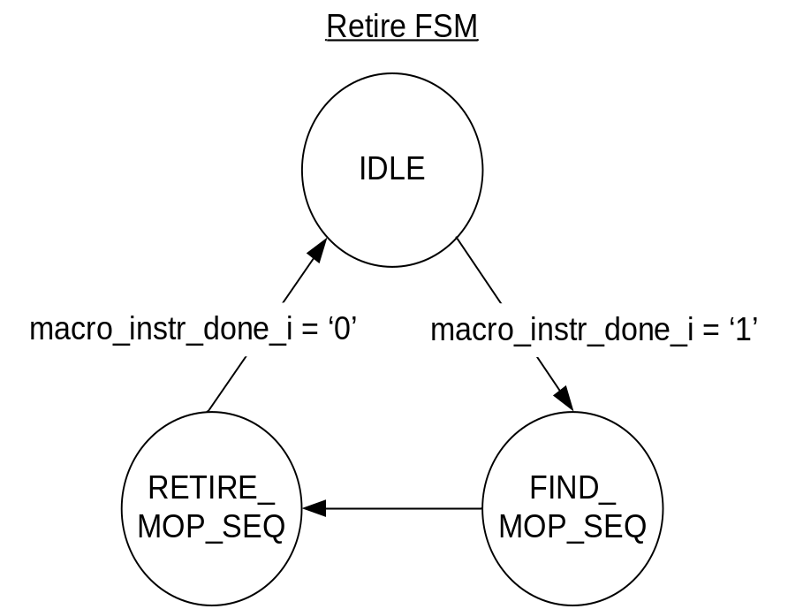

Retire FSM Outputs

STATE |  | OUTPUTS
IDLE | 00 | retiring_busy_o <= '0';  find_mop <= '0';  retire_mop <= '0';
FIND_MOP_SEQ | 01 | retiring_busy_o <= '1';  find_mop <= '1';  retire_mop <= '0';
RETIRE_MOP_SEQ | 10 | retiring_busy_o <= '1';  find_mop <= '0';  retire_mop <= '1';

Files of the Block

Source Code

Cmd_translator_m_op_table.vhd

Header Code

issue_reply_pack.vhd

